Case 0 : ----- when A = 0v and B=0v ---- op is 5v (Vcc) (in cutoff region -operating as open switch – full Vcc available at op)

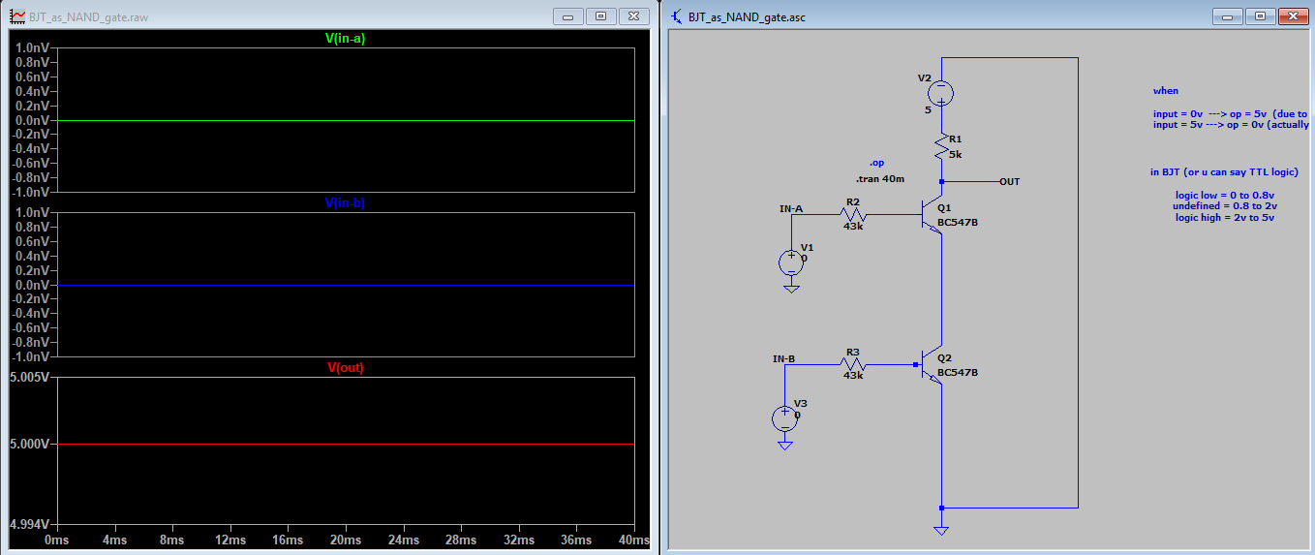

Case 1 : ----- when A = 0v and B=5v ---- op is 5v (in cutoff region -operating as open switch – full Vcc available at op)

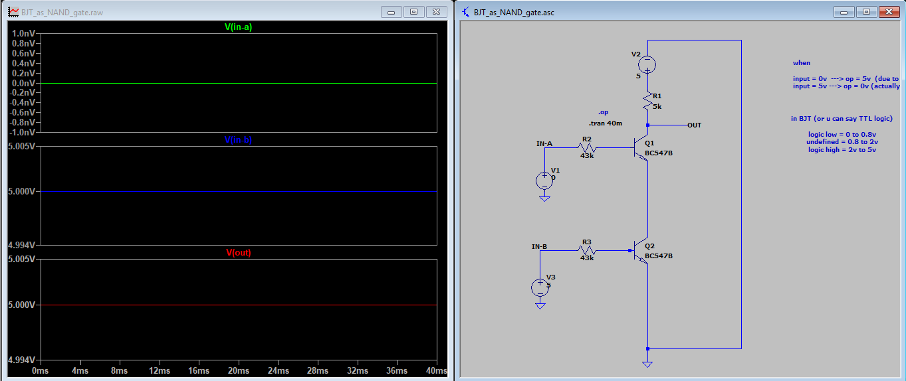

Case 2 : ----- when A = 5v and B=0v ---- op is 5v (in cutoff region -operating as open switch – full Vcc available at op)

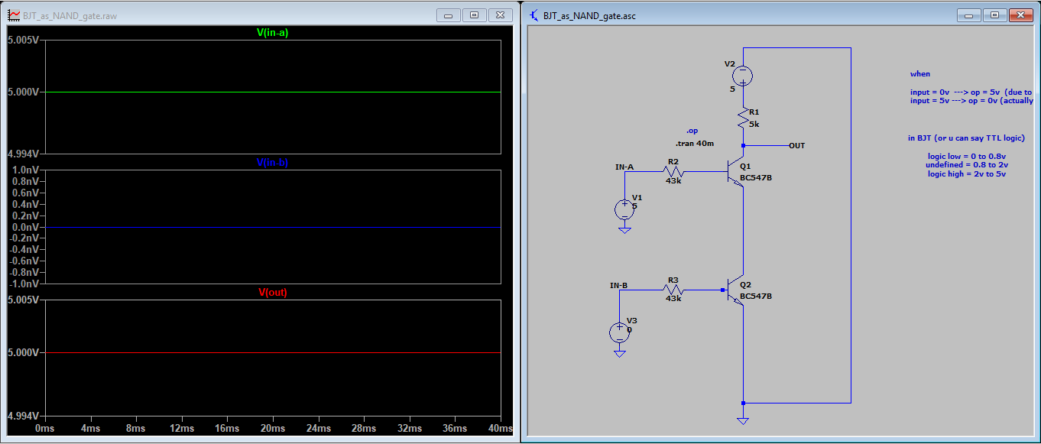

Case 3 : ----- when A = 5v and B=5v ---- op is 0v (in saturation region -operating as closed switch – almost 0v available at op (in reality actual op is equal to (Vce of Q1 + Vce of Q2) )

